Department of Information Technology, College of Engineering and Informatics Industry Stream Project

Industry Stream Project Student: Eanna Hegerty (12232385)

Supervisor: Enda Barret

Date of Submission:

Table of Contents

Introduction: 3

Document Overview 3

Personnel Statement: 3

Personnel Goal and Objectives: 4

Stakeholders: 4

Initial Statement of Problem & Advancements 5

Additional technologies incorporated 5

Software Purpose 6

Project Requirements: 6

Initial Requirements 6

Added Requirements 6

Key Challenges 7

Project Success & Evaluation Criteria 7

System Definition: 7

Development Life Cycle Methodology 7

System Design: 7

Design Pattern: 7

Technology Outline: 7

Research & Training: 7

System Overview: 8

Devolvement Practises & Processes 8

General Constraints: 8

Testing: 8

Future development 8

Technologies Used 8

# Introduction:

## Document Overview

This document will outline all the activities, goals, experiences and processes that were undertaken throughout this project. By reading this document the reader should be able to gain a full understand the stand point in which the me the developer was at when under taking this project and the journey I took to till creating this document. The reader should also have a good understanding of how the technologies, design pattern and different serval important functional aspect of the project.

## Personnel Statement:

Before undertaking the industry project my prior experience in technologies were very limited. I had had a good understanding of MySQL and had just done a full semester of Java and internet programming (html & css). I had never built any application from start to finish or any real programming experience outside of what I had learnt from first semester 1. I had never written a line of code in JavaScript and by the end of the project I had created a fully functioning web application that not only used JavaScript, D3.js and Angular.js in the front end I also created a backend that consisted of Node.js, Express.js, Passport.js and Mongoose.js all of which are either libraries or frameworks for JavaScript. This along with creating a mongo database based on NoSQL again I had never seen before. These technologies were all self-taught and used to create an application that include several instances of RESTFUL CRUD API’s and hosted on a virtual machine on the AWS cloud.

## Personnel Goal and Objectives:

My personnel goal and objects for this project from the outset were:

1. To build a product that achieves and surpasses my functional requirements.
2. To incorporate technologies that is used by my industry partner AltoCload.
3. To develop my understanding of design patterns.
4. To become experienced in as many real world third party devolvement software.
5. To broaden by general information technology knowledge.
6. To implement testing, as to prepare me for real world development.

## Stakeholders:

The stakeholders involved in this industry project are as follows:

1. Developer: Eanna Hegerty
2. Supervisor: Enda Barret
3. Industry Partner: AltoCloud
4. Course Administrator: Enda Howley
5. University: NUIG
6. End Users

## Initial Statement of Problem & Advancements

In my initial Project Definition Document I defined a statement of problem and listed the below technologies that my project must incorporate within the project

* “Become familiar with AWS (Amazon web Services)
* Create an Ubuntu instance on EC2 and become familiar with Ubuntu OS.
* Create a web application on an Ubuntu EC2 instance will be built using the MEAN stack (MongoDB, Express.js, Angular.js, Node.js).
* Creation of RESTful APIs on the backend using Express (Node.js) which will read from the MongoDB database and carry out analytics.
* Use Angular.js to make client side calls to the server side APIs which return JSON data and display the data on the client.”

And from the above list of technologies I drew up the following project outline

“Create an online application that will allow users/retail staff to view reports generated through analytics in regards to current stock levels, orders, employee details etc. Different users will be able to view different reports depending on their administration rights or personally requested reports.”

I believe not only have I incorporated the above technologies and created the required web application I have also surpassed the above outline in functionality and technologies used. The purpose of which were to including more technologies in which AltoCloud uses on a daily basis to lessen the jump from university to my internship. And use software that is commonly used in industry that would complement the project and widen its scope.

### Additional technologies incorporated

1. GitHub
2. Docker
3. Putty
4. WinSCP
5. Postman
6. RoboMongo
7. Single Page Applications
8. Bootstrap
9. D3.js
10. JetBrains Webstorm

# Initial Requirements & Advancements

When I submitted the Project Definition Document I listed the below requirements for my project

1. Create a web application that can be accessed from distributed devices

2. Create an web application is bout desktop and mobile friendly

3. Create a database that created, edits and stores user information a privileges

4. Host the Web Application with AWS on an Ubuntu instance

5. Construct the application with the MEAN stack

### 

### Added Requirements

During development I aimed surpass these requirements with the inclusion of the following

1. During the devolvement of any software project the requirements of the project change and expand. I am happy to as not only did I achieve all of the above requirements but I added to them also.

2. The application must be a single page application

3. The application must be built using source code management tools that a hear to dev-ops best standards

4. The web application must use docker.js for easy of movement

Now that the problem definition has be solved and surpassed in technologies used and requirements outlined , we can use the software purpose outline below to define the solution to the problem definition.

# 

# Software Purpose

In today’s word company are demanding more from software. This demand has been driven by the advancements in technology and broadband speeds. Users can now access their personnel email and documents from the cloud anywhere along as they have a browser. Gone are the days of downloading your email too your desktop, or having a vital piece of software on one computer in one location. Owners, managers and admin need access to vital information on the go. This need is the purpose and driving force of my industry project. The software that I have created is designed for head office, so top level management can get real time, up to date information and analyses from any device with internet access. Top management can track sales, stock levels, employee performances, best/worst customers, top selling products, order information, delivery status and even request the development of a brand new report or analysis’s all from the comfort of home or on the go.

# Use Case

# Story Boards

# Design Pattern

# Development Life Cycle Methodology

# System Design:

# Technology Outline:

# Research & Training:

I undertook extensive training prior and during development of this industry project. Before I started coding my project I undertook getting familiar with AWS (Amazon Web Service), as it was one of the requirement of my project that my application would be hosted on this cloud hosting vender. I spent the best part of 2 weeks with this application and the surrounding concept and supporting applications. Some of these research activities include setting up an AWS account, getting familiar it’s GUI. Also learning concepts and technology such as virtual machines, images, PuTTY, WinSCP, instances, public and private key authentication. All of the above I used prior to coding and hosting my project which allowed me to easily carry out hosting my application 3 months later after it was developed.

Prior to development I also under took training from several online services such as the New Boston website (Node.js & Mongodb), Udemy (Angular, Node.js and JavaScript) ??. Along with this training I also took part in serval YouTube courses in order to further my knowledge. In particular the most beneficial resources I found was the Udemy course I under took which I total took 20 hours of training material and easily another 30 hours of implementing, exploring and understanding the material.

# System Overview:

# Devolvement Practises & Processes

# General Constraints:

# Testing:

# Future development

# Technologies Used

1. GitHub
2. Docker
3. Virtual Machine concepts
4. Putty
5. WinSCP
6. Private and public key authentication
7. Postman
8. JSON Data
9. VMC design concept
10. Ubuntu
11. NoSQL
12. RoboMongo
13. API’s
14. Single Page Applications
15. Bootstrap
16. D3.js

# Testing

Test Framework

* Postman

White Box

Black Box Testing

**Test Title:** Test API security

**Test Description**

The following test was designed to test the security of end points (api’s). User’s must be logged in to gain access api’s information. To test this process I used post man to hit URL’s with appropriate data while they were logged out.

Expected result

* No api data should be sent back and user should be redirected to login page

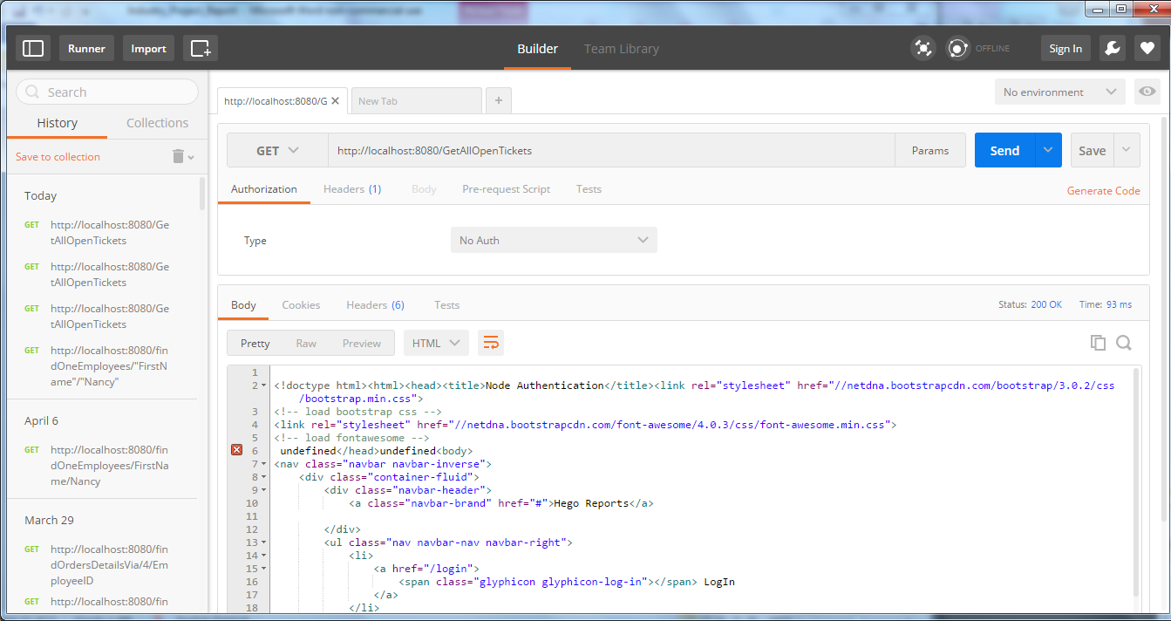

**Result Test**

No user is logged in and api end point is hit with a get http request using postman. The user received no api data and was redirected to the login page.

* Test Passed

Black Box Testing

**Test Title:** Test page security

**Test Description**

The following test was designed to test the security of page access. User’s must be logged in to gain access to any webpages. To test this process I used chrome, safari and explore web browsers to try and gain access to given webpages while no logged in.

Expected result

* User should be redirected to index page where they have the option to login

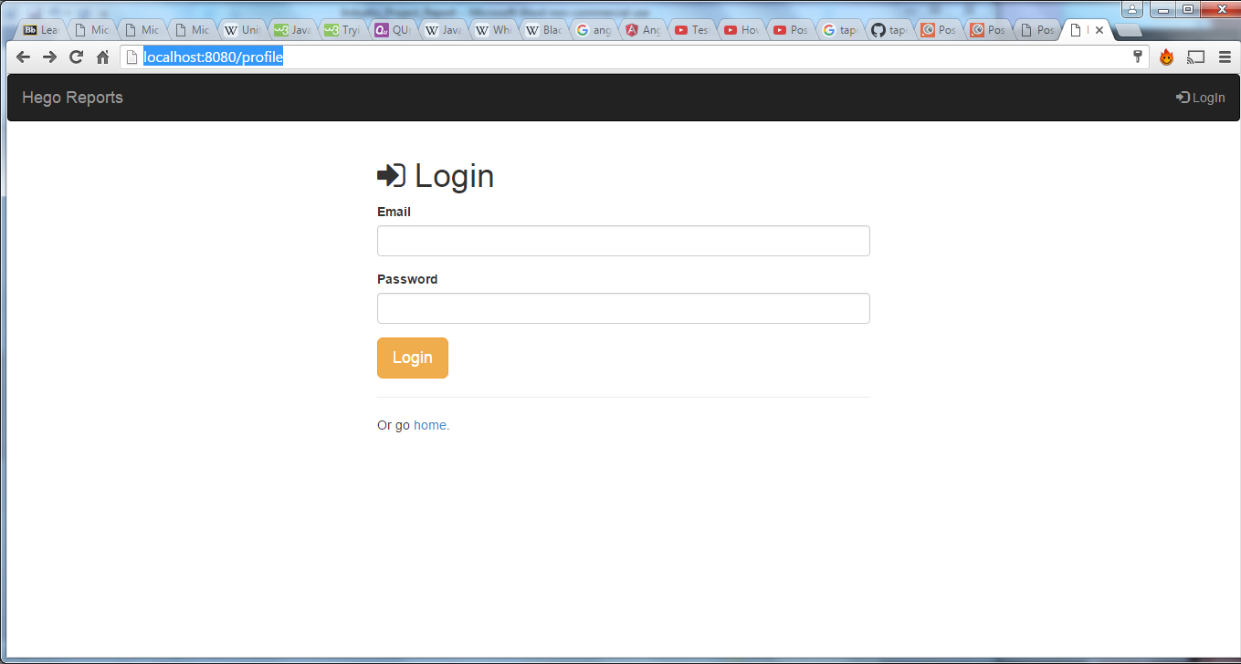

**Result Test**

The user did not gain access to the their profile page and brought to the index page.

* Test Passed

**Test Title:** Test webpage admin rights

**Test Description**

The following test was designed to test the administration rights of users. A user with manager security rights does not have access to administration pages. This test is designed to test can they access the pages they don’t have access to.To test this process I used chrome, safari and explore web browsers to try.

Expected result

* User should be redirected to no access page.

Action

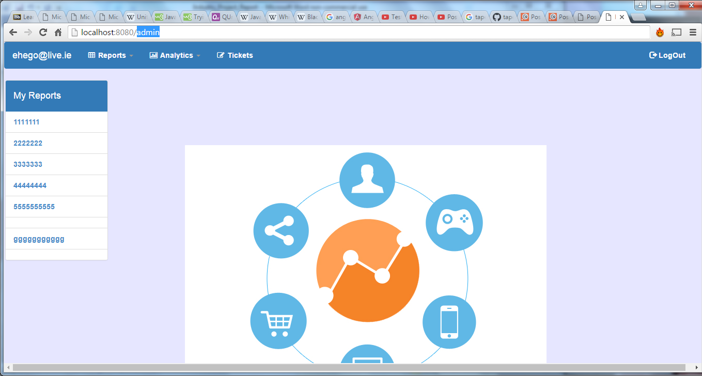

Result:

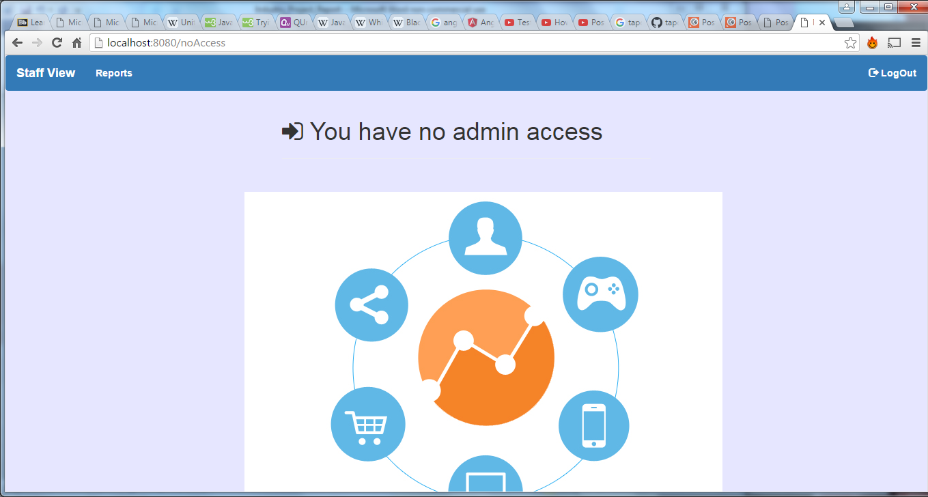

The user did not gain access to the admistration page and were kicked back to no access page.

* Test Passed

**Test Title:** Test api’s admin rights

**Test Description**

The following test was designed to test the administration rights of users in regards to api access. A user with manager security rights does not have access to administration api’s. This test is designed to test if managers can access the pages they security rights to.To test this process I used chrome, safari and explore web browsers to try.

Expected result

* User should be show the no access page.

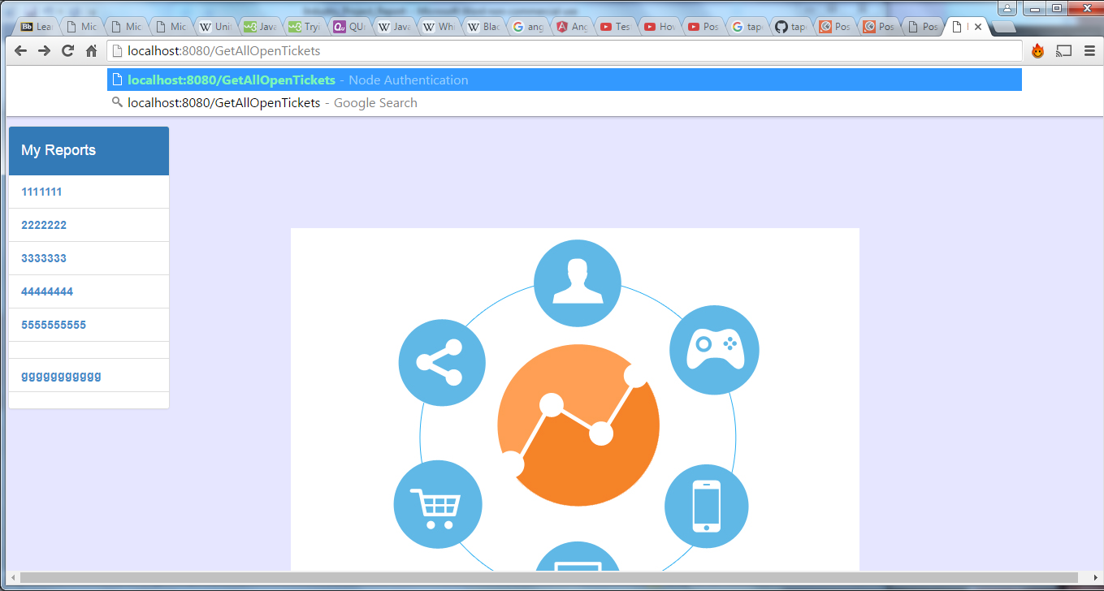

Result

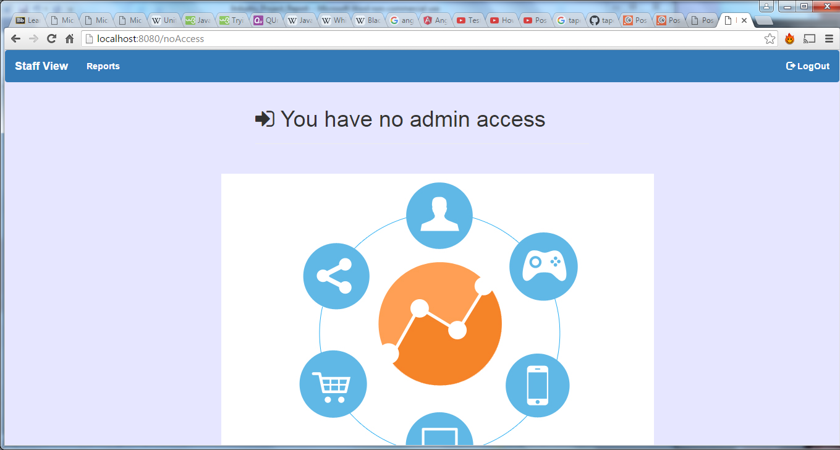

The user did not gain access to the administration api’s and were kicked back to no access page.

* Test Passed

**Test Title:** Test login functionality

**Test Description**

The following test was designed to test the login functionality of this application.

The first part of this test is to assures that a user does not gain access to the web application when they enter the incorrect login details for their account (email or password). The second part of the test is to assure that the user get redirected to their personnel profile screen, with their personnel reports setting. To test this process I used chrome, safari and explore web browsers to ensure that the test worked on several browsers.

**Expected results**

* Test 1: The user should be shown messages informing them they enter wrong email.
* Test 2: User should be shown messages informing them they enter wrong password.
* Test 3: The user should be brought to their profile screen displaying their email address and there personnel reports.

Test 1 action: User enter wrong email address

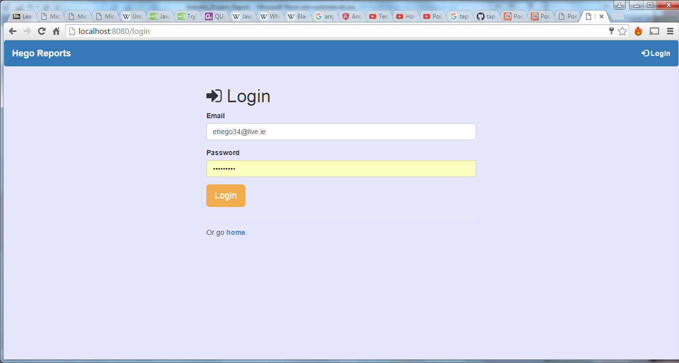

Test 1 Result:

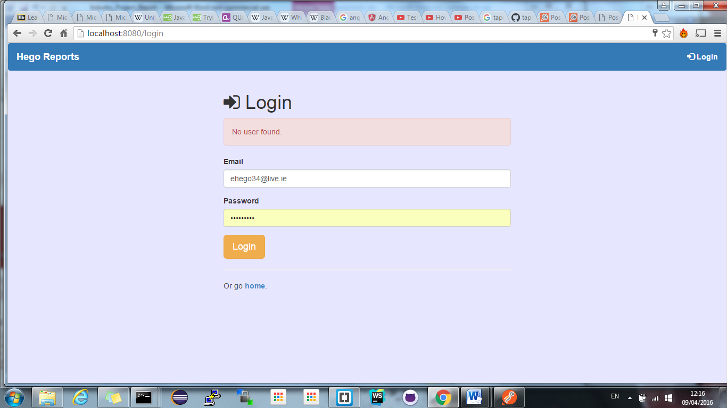

**Test 1:** Passed

Test 2 action: User enter wrong password

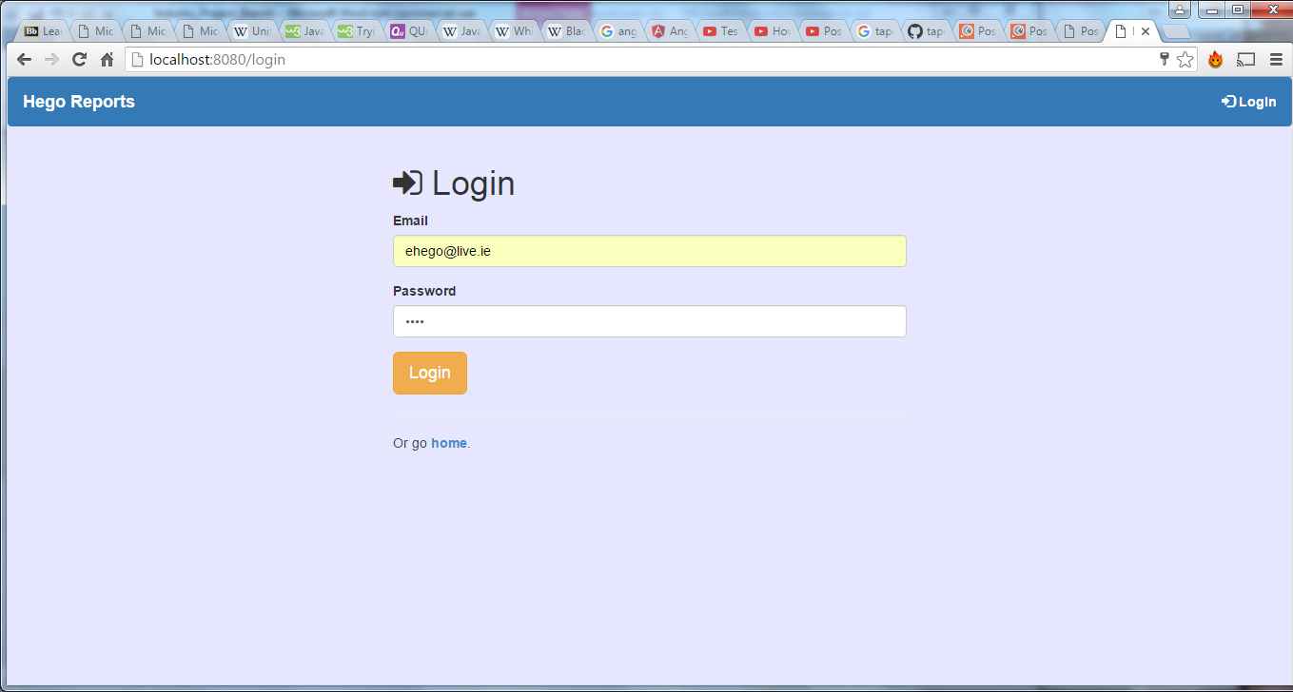

Test 2: Result

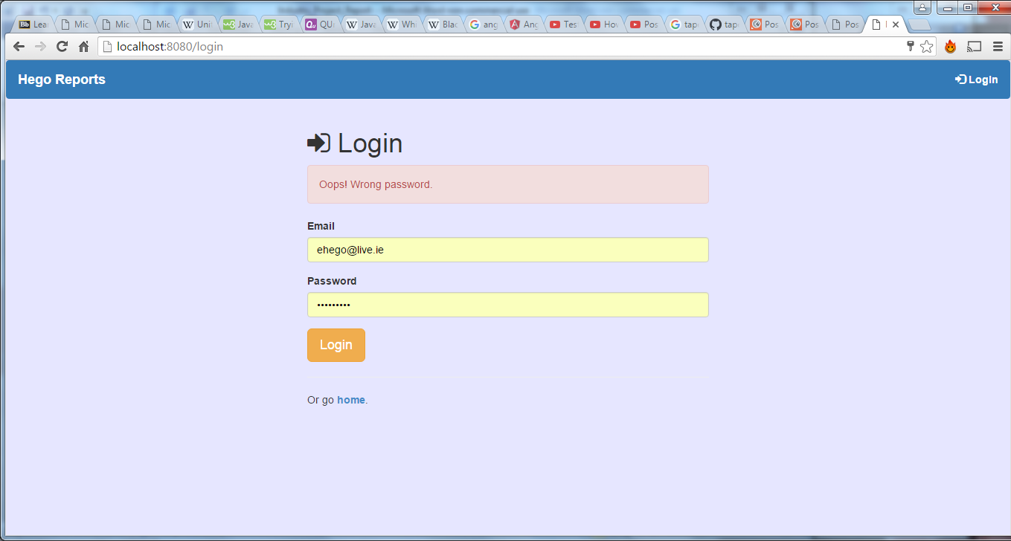

**Test 2:** passed

Test 3: action: User enters correct details

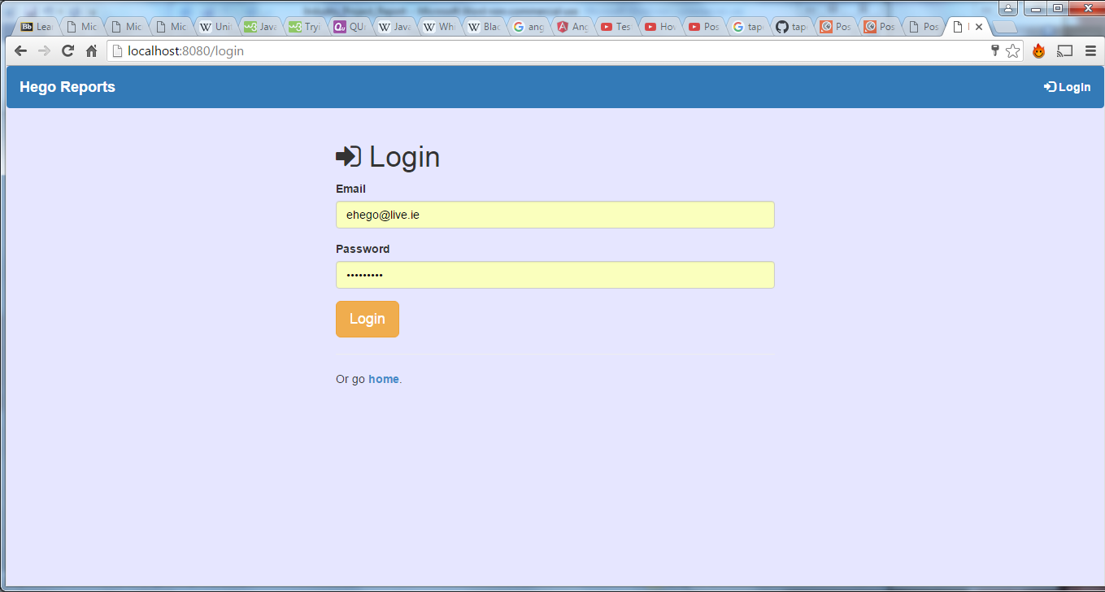

Add screen shot

**Test Description**

The following test was designed to test the register functionality of the system.

The first part of this test is to try and register a new user with an email and password.

The second part of the test is to assure that the user can log in.

To test this process I used chrome, safari and explore web browsers to try.

Expected results

* Test 1:Message showing user has been registered should be shown
* Test 2: Database should include new users.
* Test 3: The user should be able to log in with their details and get brought to their profile page displaying their details.

Test 1 Action: Register new user details

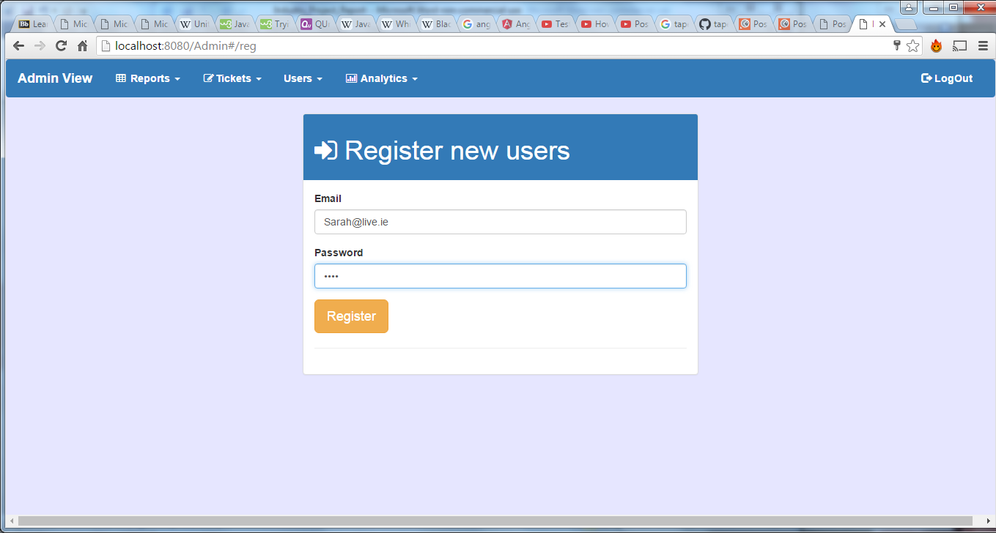

Test 1 Result Message displayed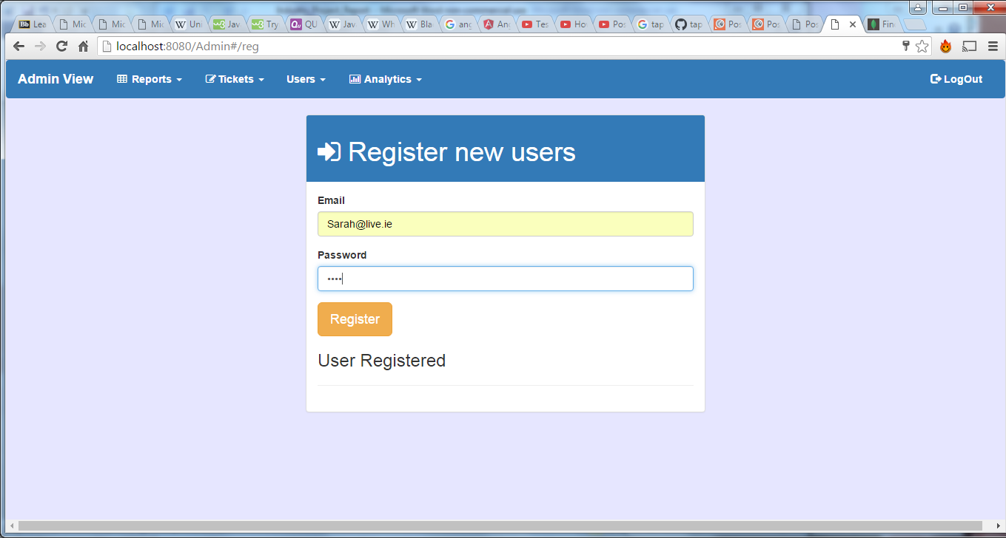

Test 1: passed

Test 2: User added to database

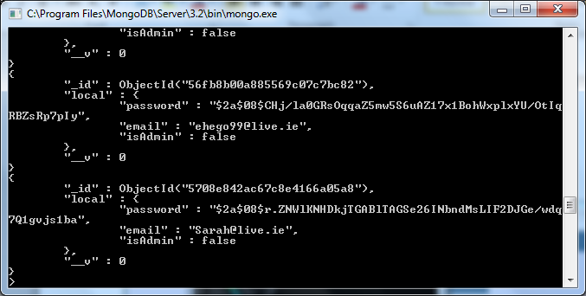

Test 2: passed

Test3: Login as with user details

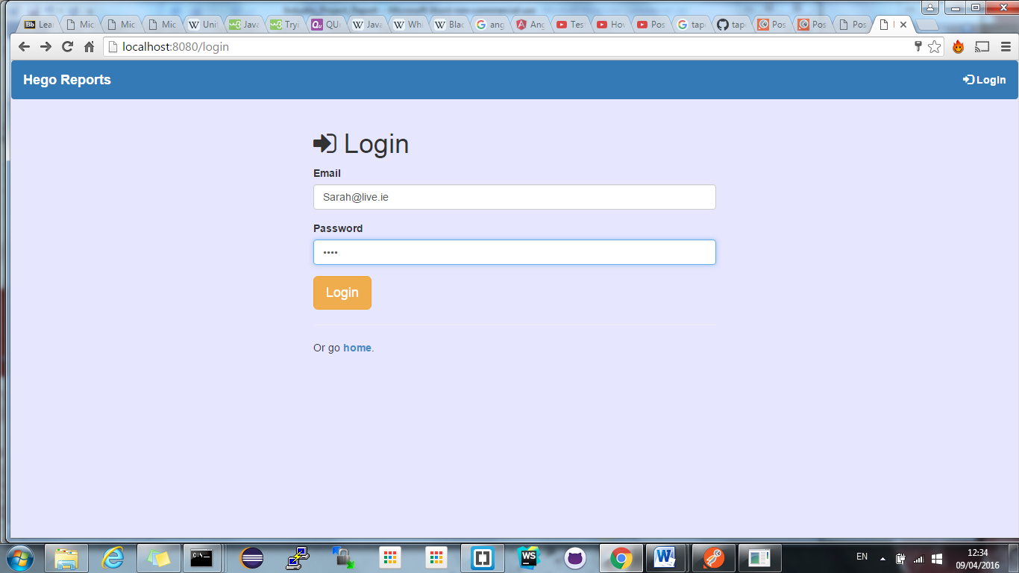

Result : [Sarah@live.ie](mailto:Sarah@live.ie) displayed on profile screen, user logged into newly created account.

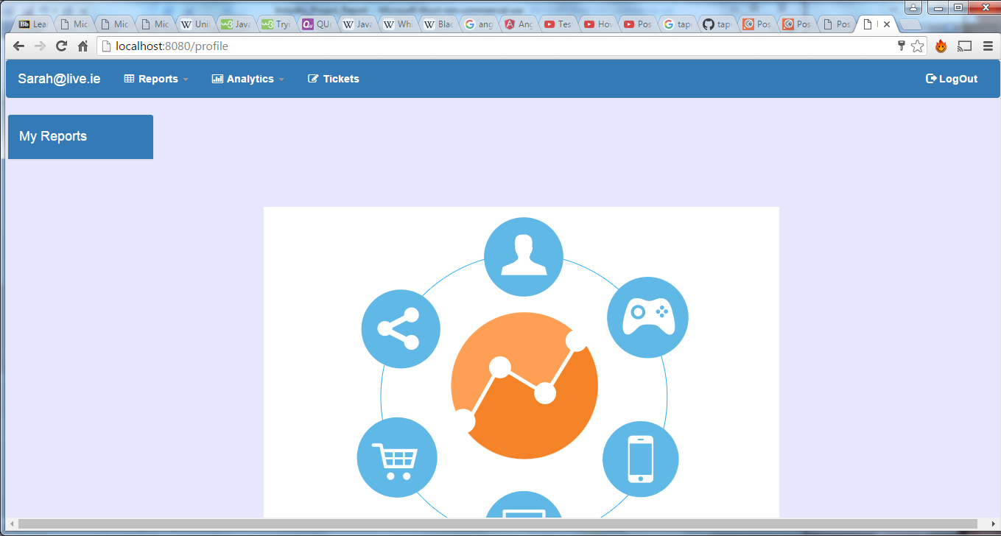

Test 2: Passed

**Test Title:** Test User profile reports generator

**Test Description**

The following test was designed to test the assignment of personnel reports to users (each user has personalized report on profile screen).

The personnel reports for a user will be entered and registered to a user via their email address through the admin profile reports form. Once the reports have been registered user should be able to access these report via their profile page.To test this process I used chrome, safari and explore web browsers to ensure that the test worked on several browsers.

**Expected results**

* Test 1: The user should be shown messages informing them they registered a reports
* Test 2: Entry in the database should show reports assigned to users email
* Test 3: The users hould be able to access reports from side menu on profile page.

Test 1: Action register reports to users email address

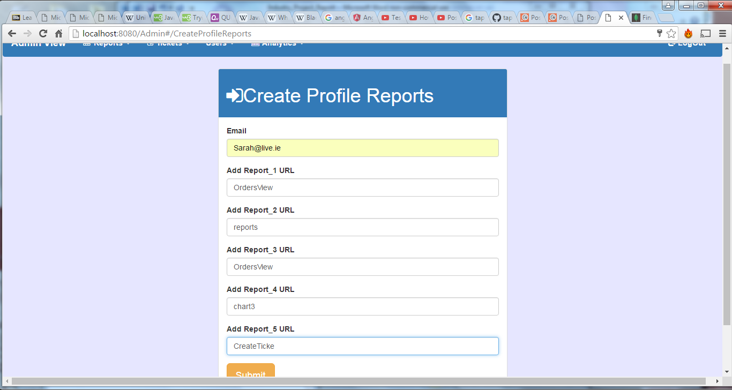

Test 1: Results: Message has been shown

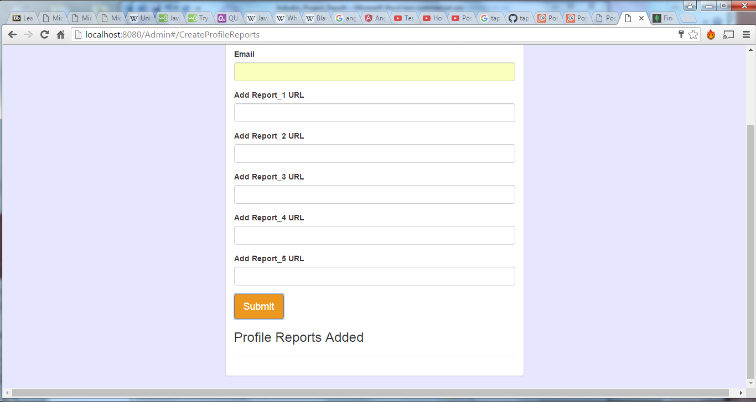

Test 2: Results: Reports added to database to users email address

Test 2: Passed

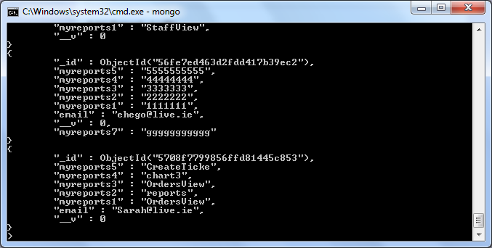

Test 3: Results: Reports added to user profile page in side meu, user can now access new reports.

Test 3: Passed

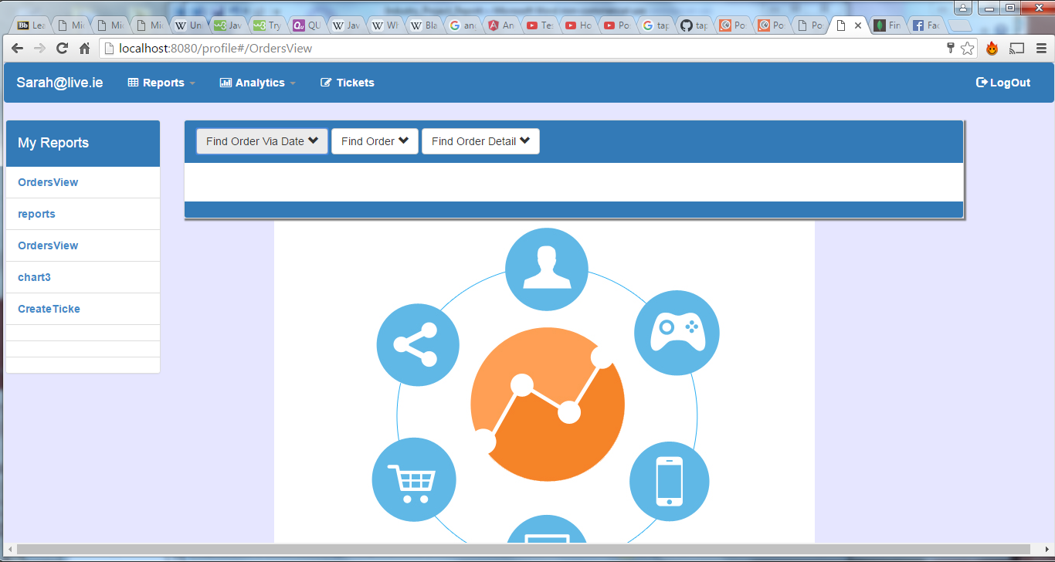

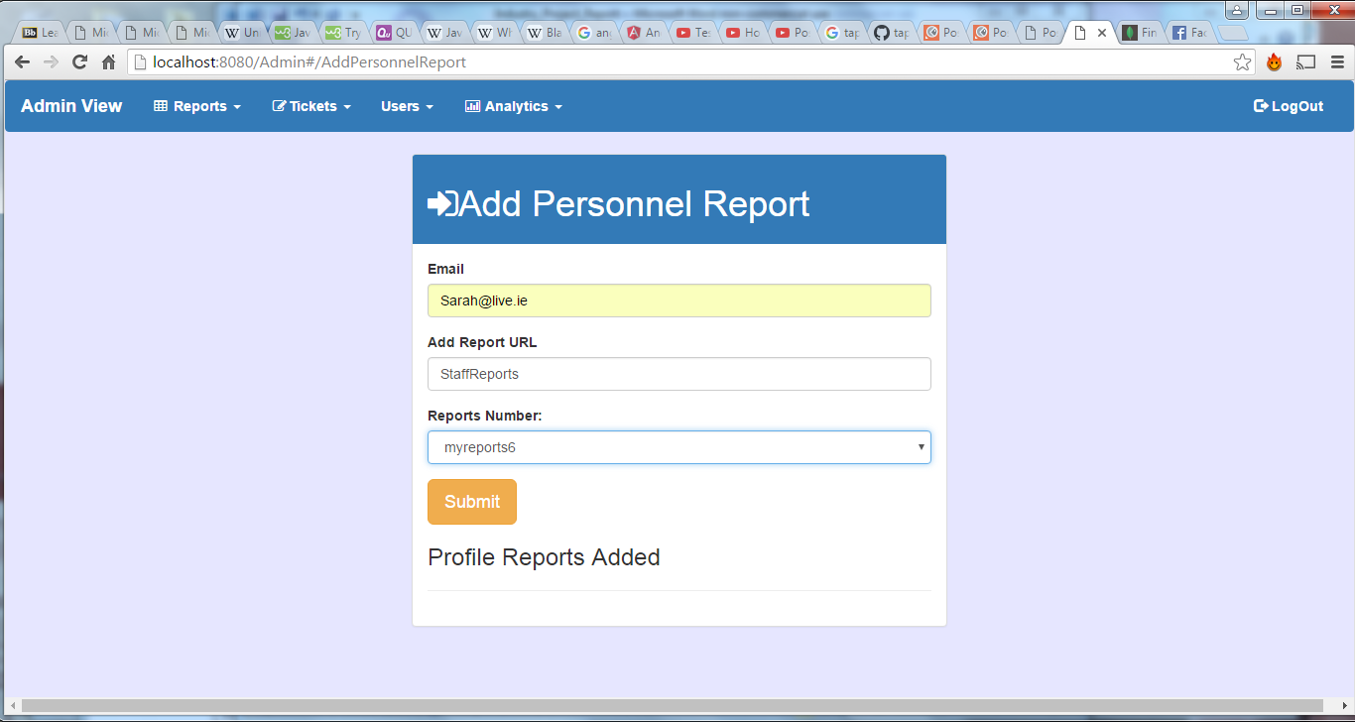

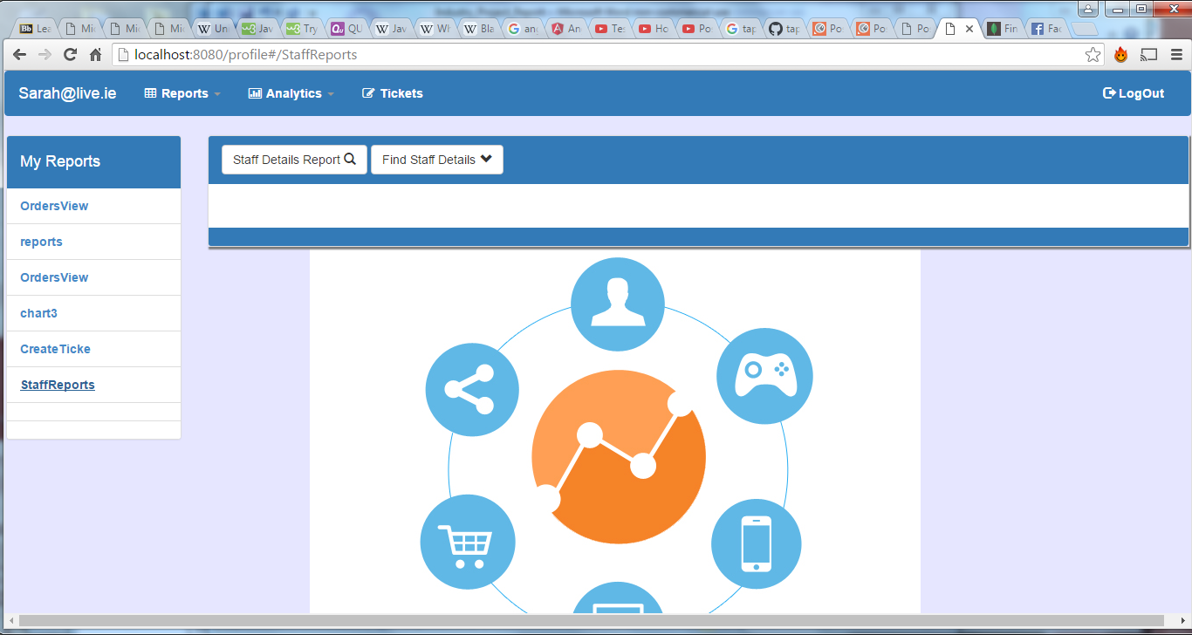

**Test Title:** Test Application device independence

**Test Description**

The following test was designed to test that the application could be used on a wide range of devices, from desktop, tablets and mobile. The test set out to prove that reports could still be accessed and view in a range of devices. be To test this process I used chrome, safari and explore web browsers to ensure that the test worked on several browsers. The test was done using several mobile device along with the different device views offered by chrome.

**Expected results**

* Test 1: The applications menu should resize on smaller screen 760;
* Test 2: Reports table should become scrollable on screen smaller that 760;
* Test 3: The users should be able chart analytics on any screen size .

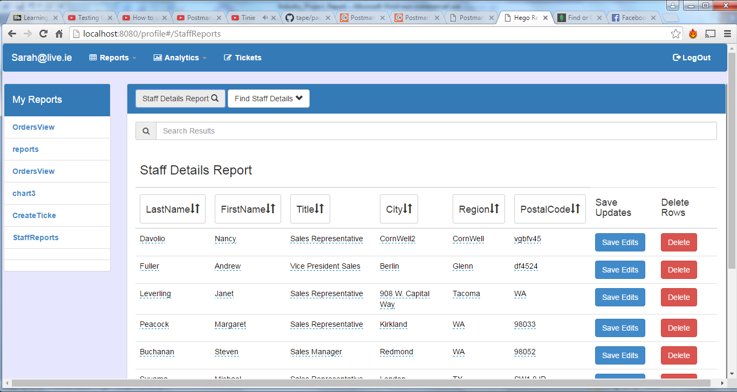

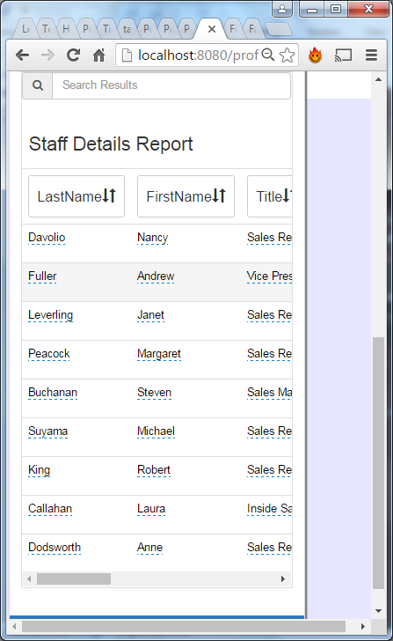

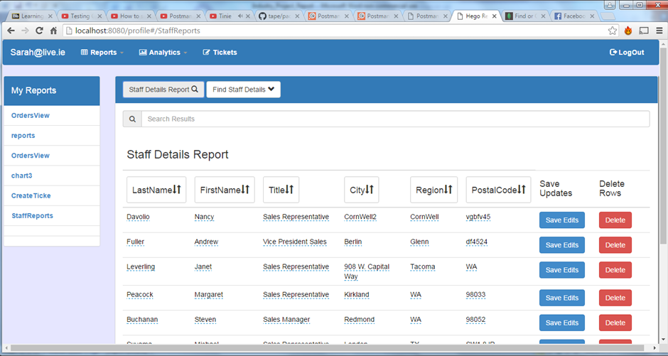

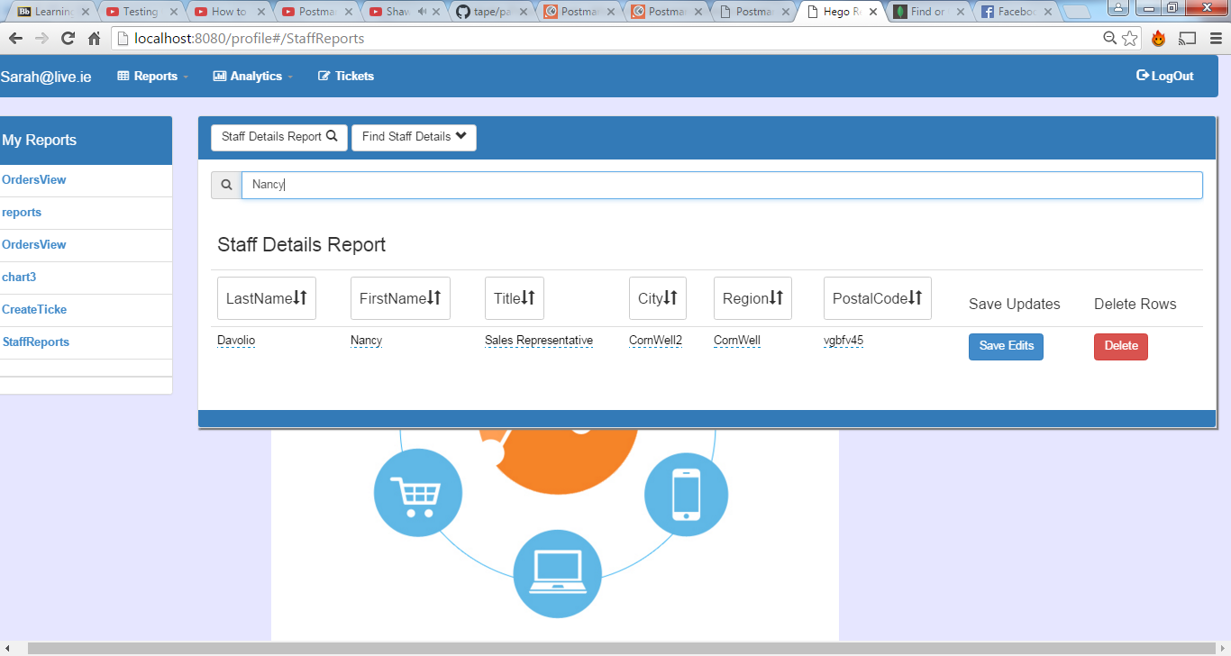

White box testing

**Test Title:** Test to get http request on api

**Test Description**

This test was created to assure that the correct data was pulled from the database. Users are able to search for employees by column values first name, last name or city. This test uses postman to test if the correct user details are retrieved depending on data entered. The end following end point was hit

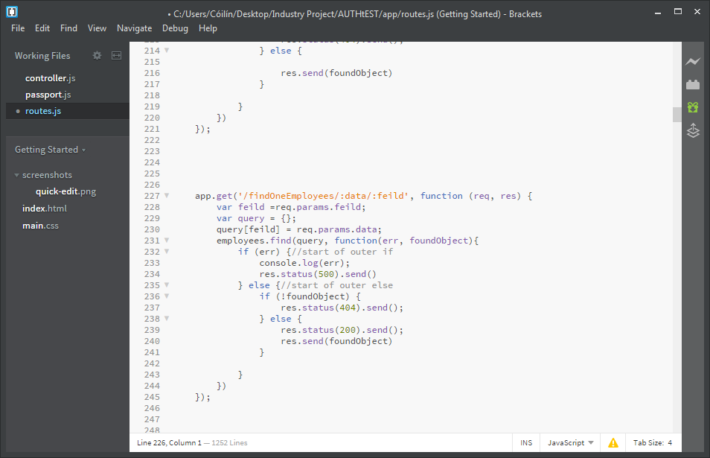

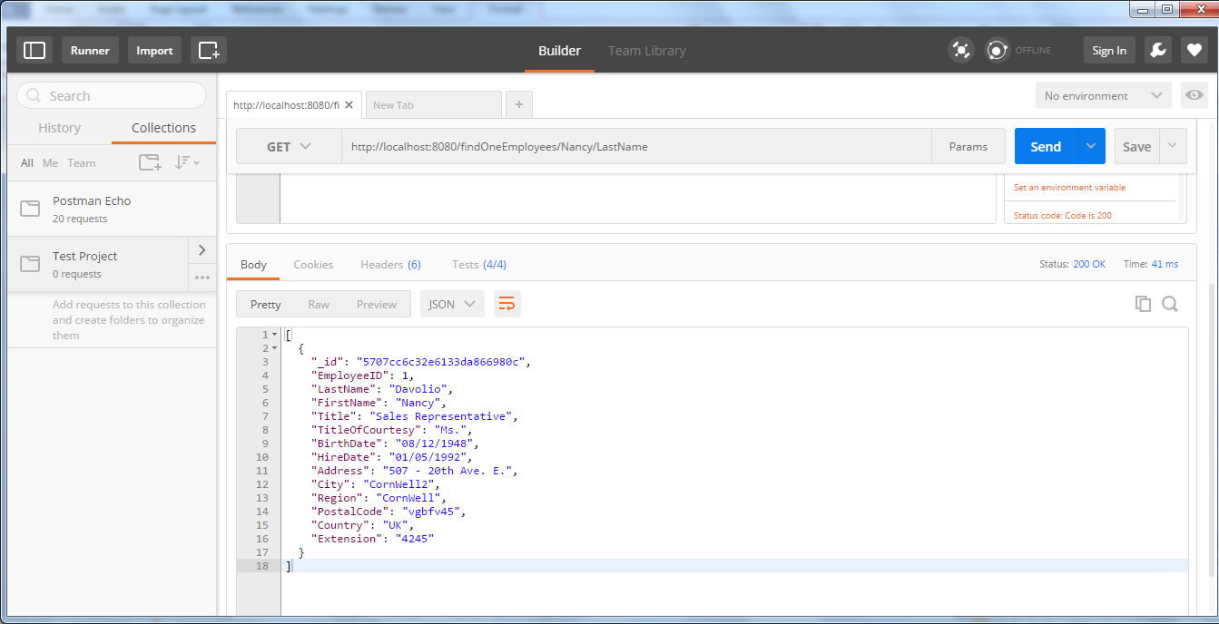

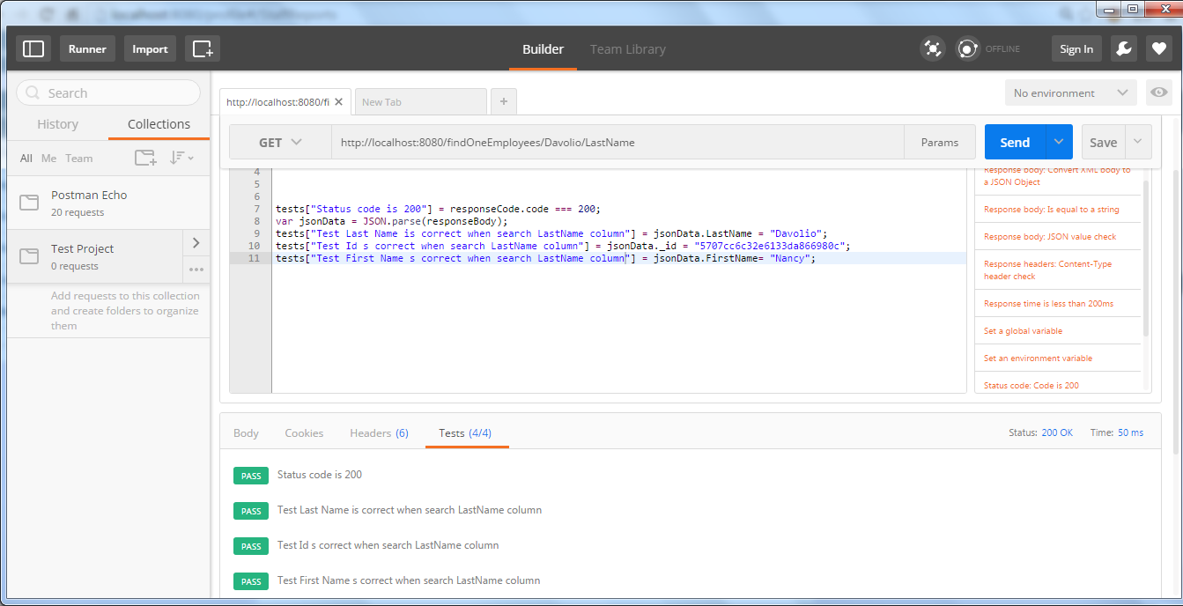

**Expected results**

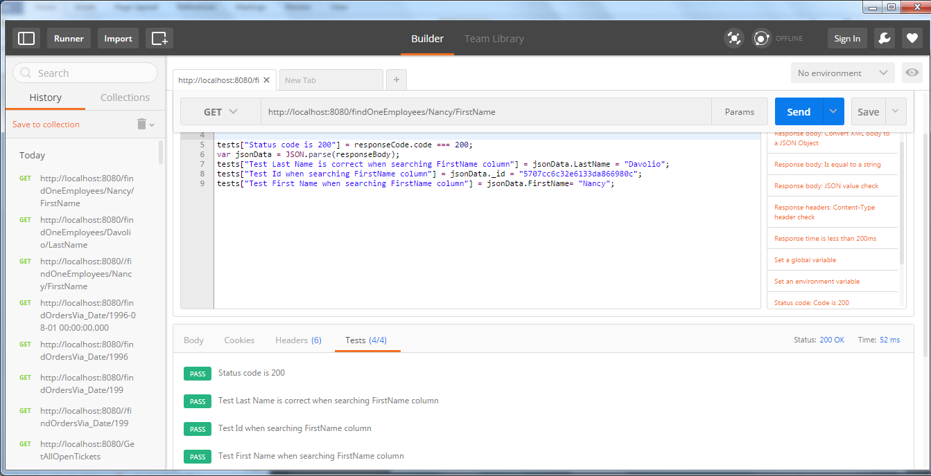

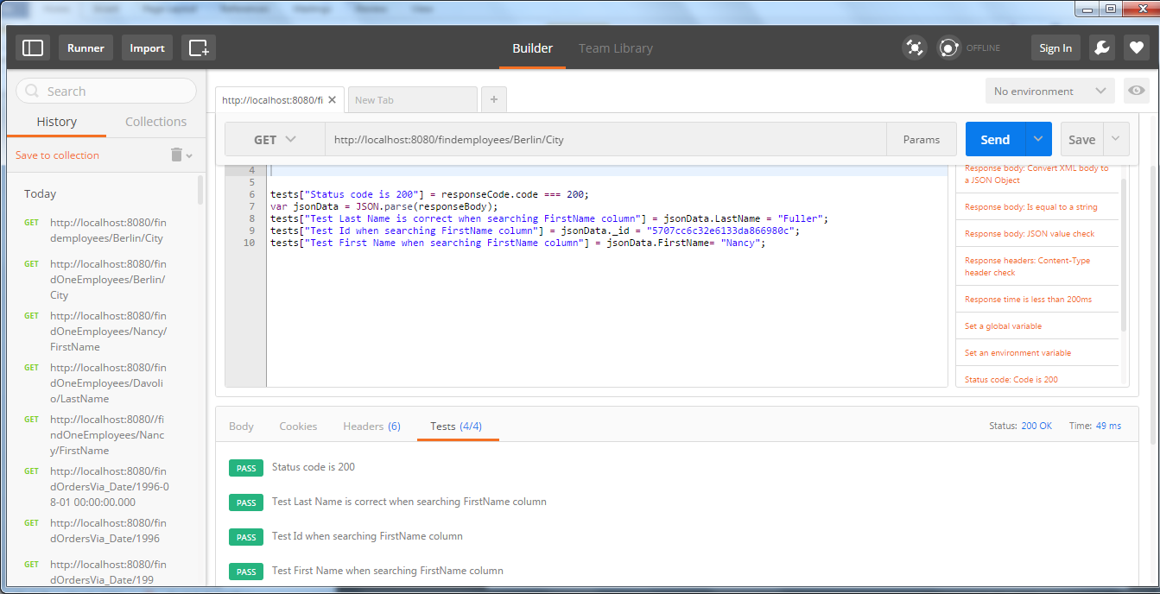

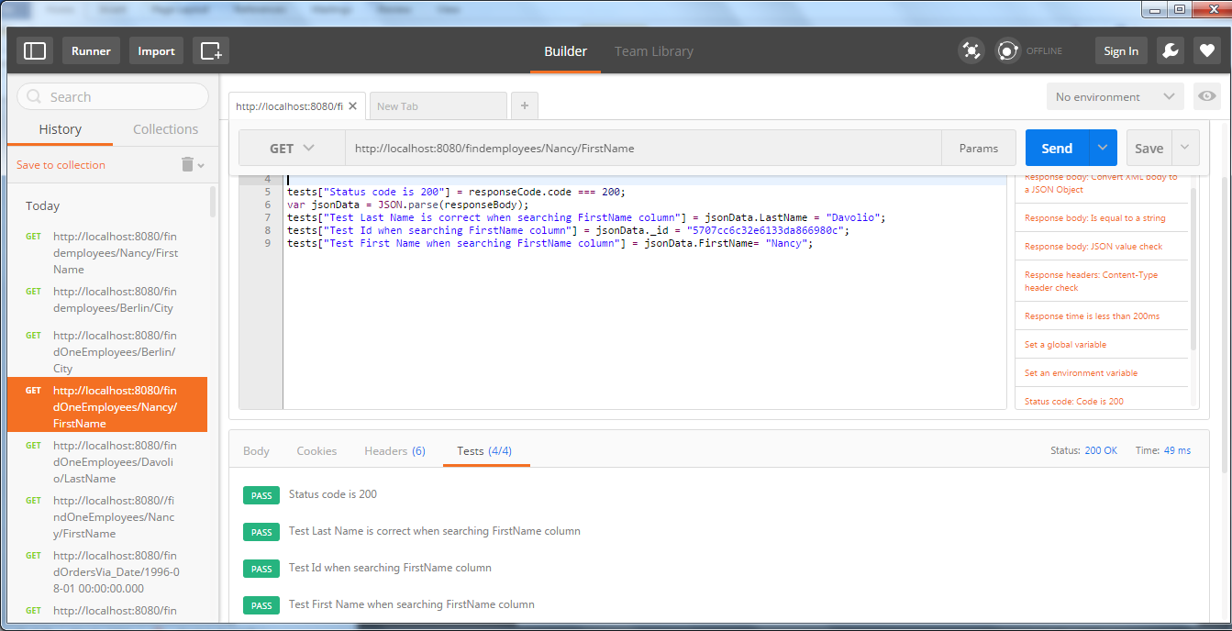

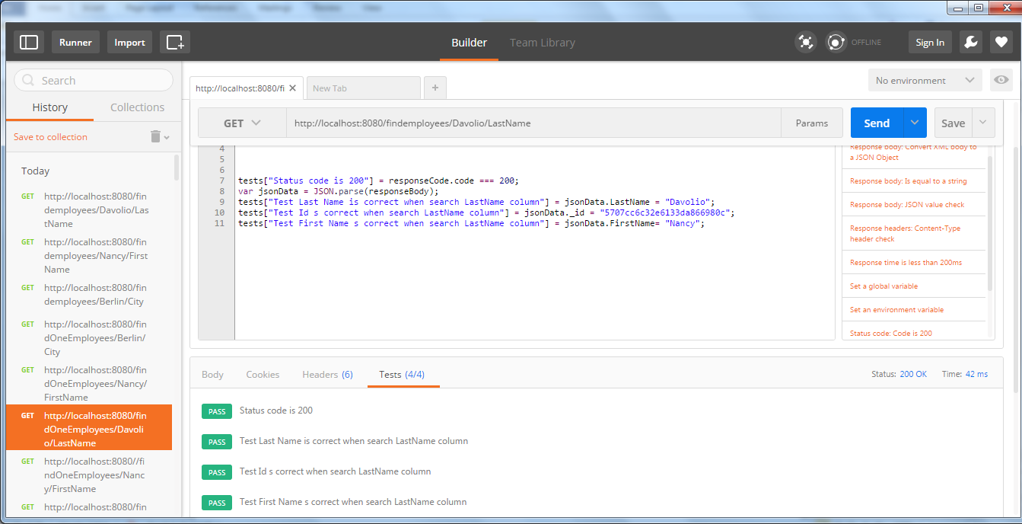

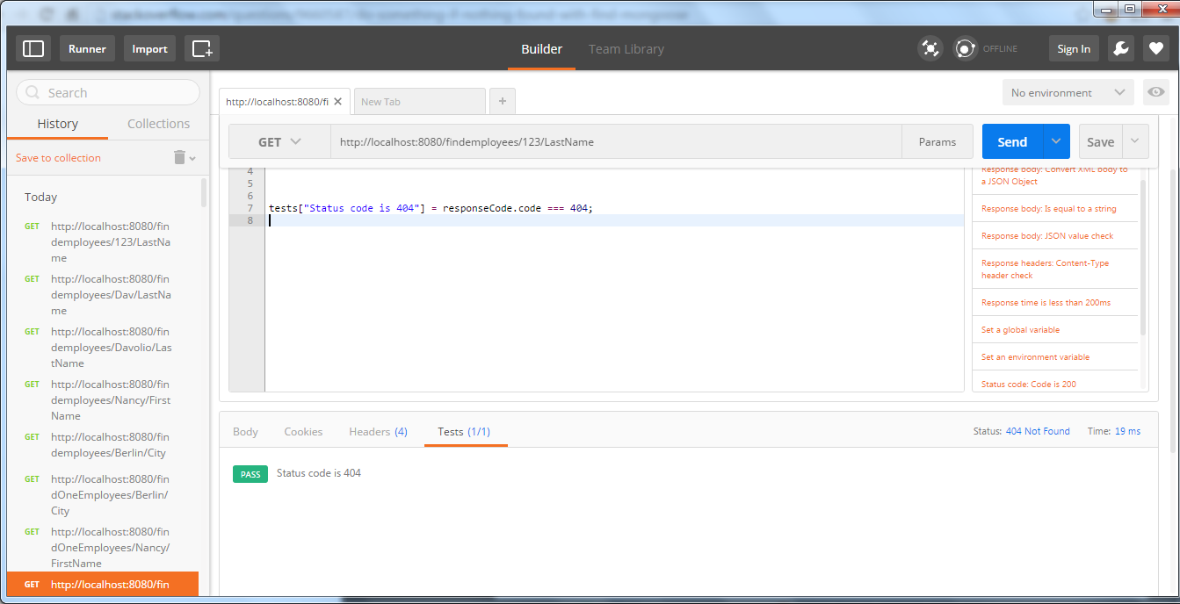

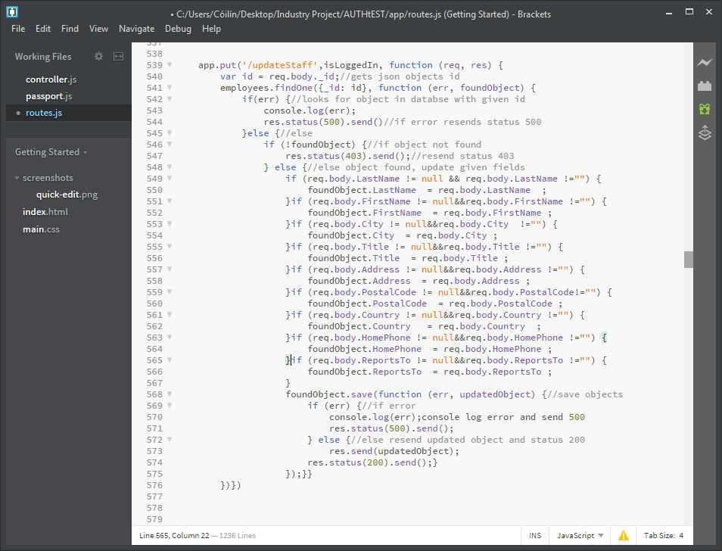

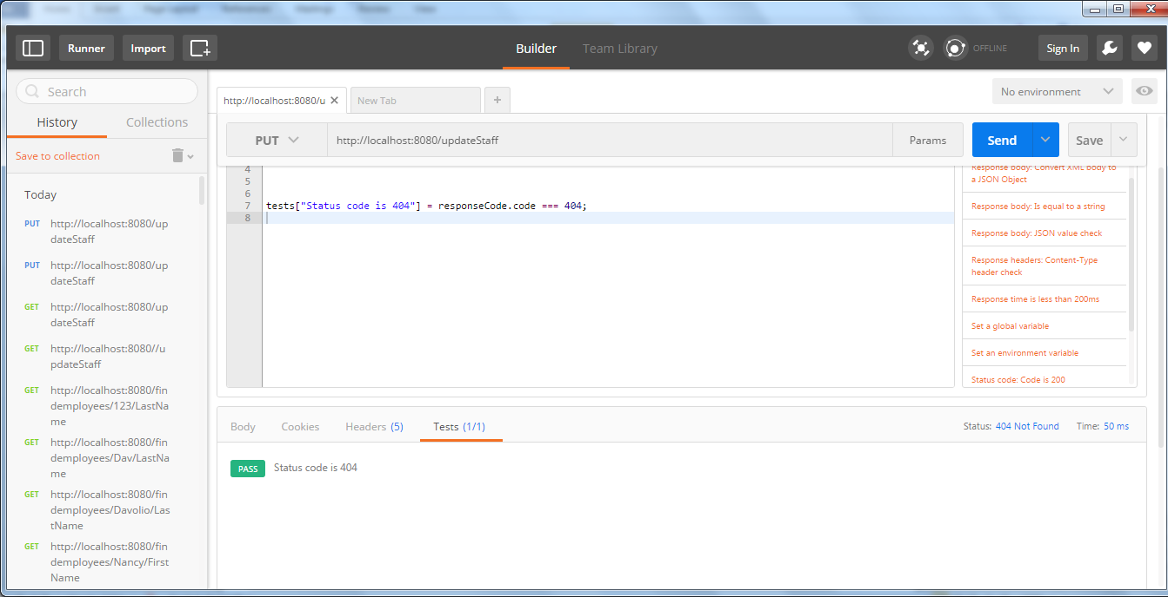

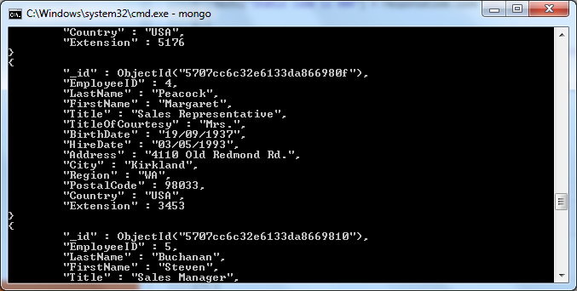

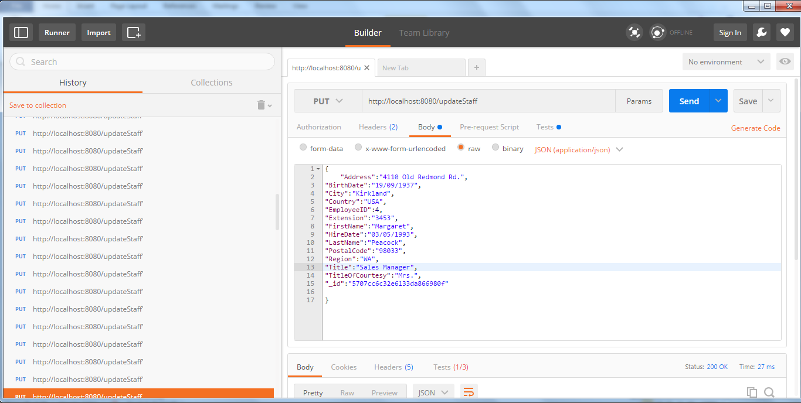

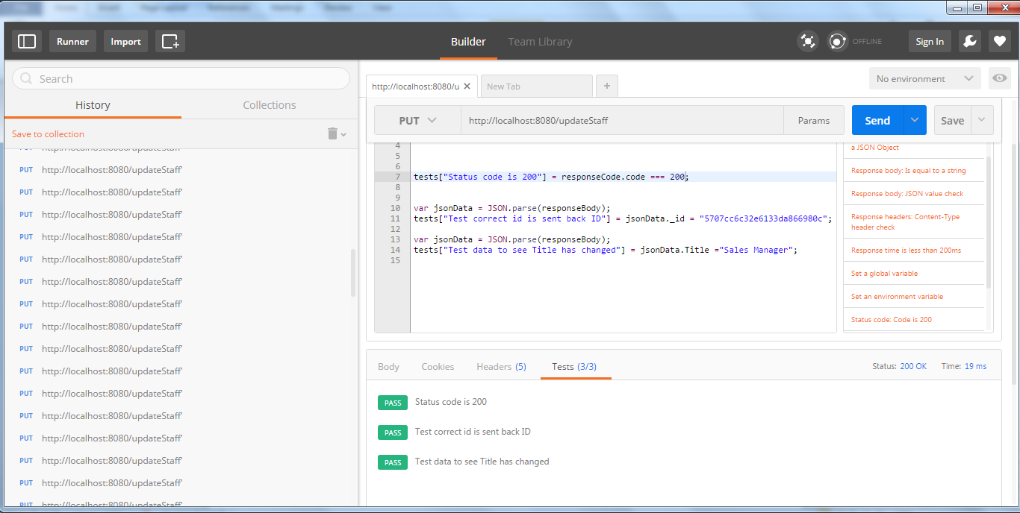

"_id":"57076133da866980f"

